Reading Series Access

Please go to: https://www-k6.thinkcentral.com/ePC/start.do
The main login page should look as follows:
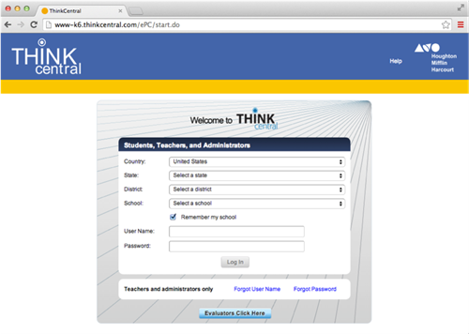

You will need to complete the following info:
Country: United States
State: Pennsylvania
District: Archdiocese of Phil Ed Office, Philadelphia 19103
School: Saint Charles Borromeo School, Bensalem

You child’s username and password is as follows:
Username:
Password:
After logging in, this should be the page you see
